Television resolution – 1920X1200

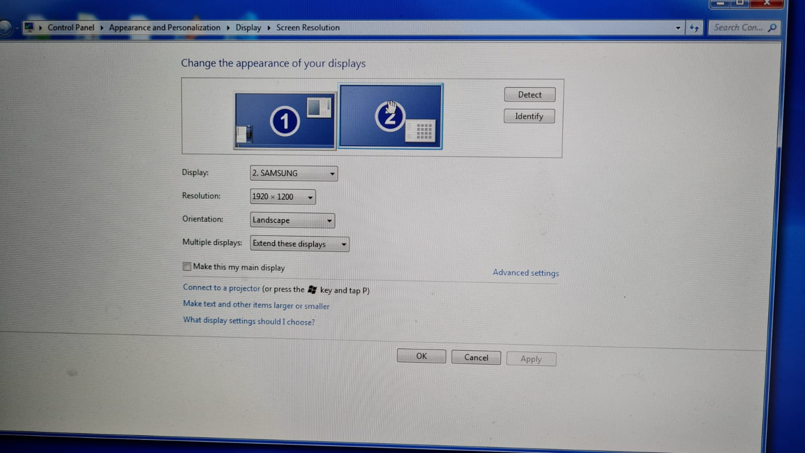Make sure TV is monitor 2 (not the main), and located on the right of the main screen.

.

Run 'MI_MainGUI.m' file from the desktop.

Press F5 (or the run buttom on the toolbar).

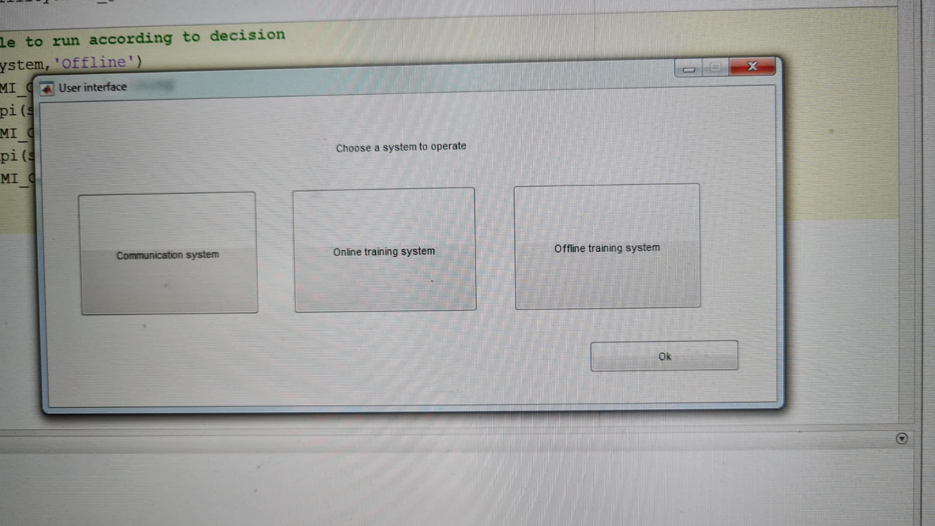Choose online training system and press ok.

Parameters on the screen should be:

Subject ID – 777

Resting state length (sec) - 60

# of classes – 3

Chunk size (sec) – 6

# of trials – 8

Sampling rate – 512

Accumilation – Unmarked.

Those are the default parameters.

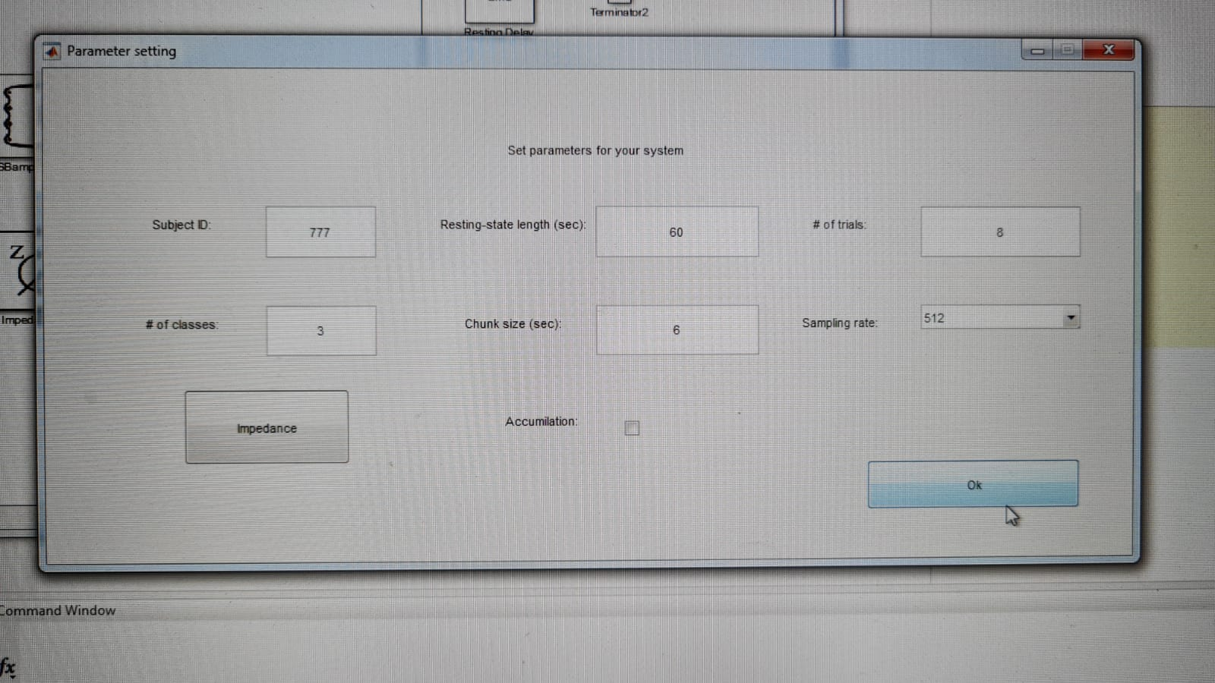

EEG headset setup

Make sure to align the EEG headset in the center. The yellow electrode on the middle of the forehead.

Put the blue clips on the ear.

Make sure all the electrode are tight to the head.

Fill gel in each electrode.

After setting up the headset. Press the impedance button.



A new Box will open.

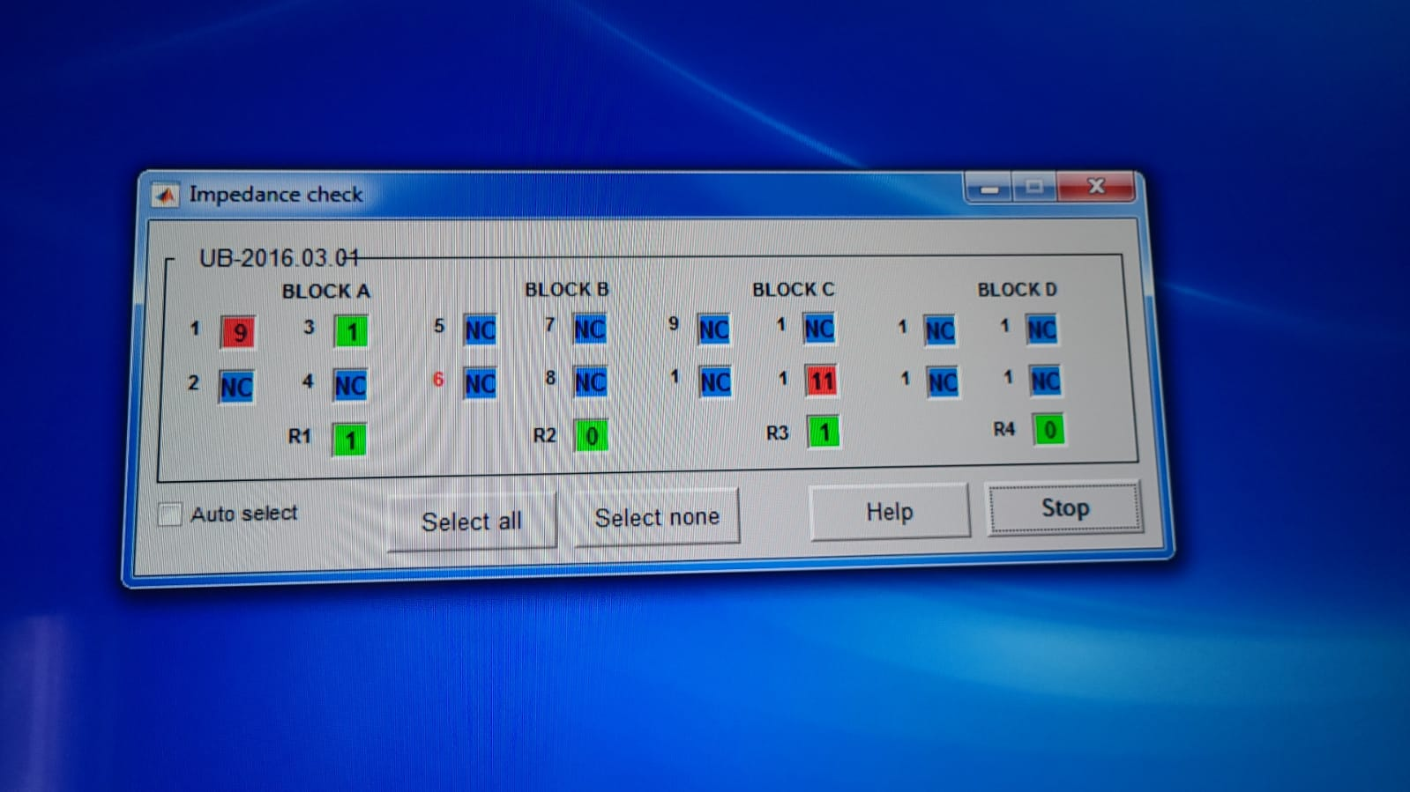

All the squares should be green. Each square number corresponds to an electrode (number is written on the electrodes).

After all the squares are green press stop.

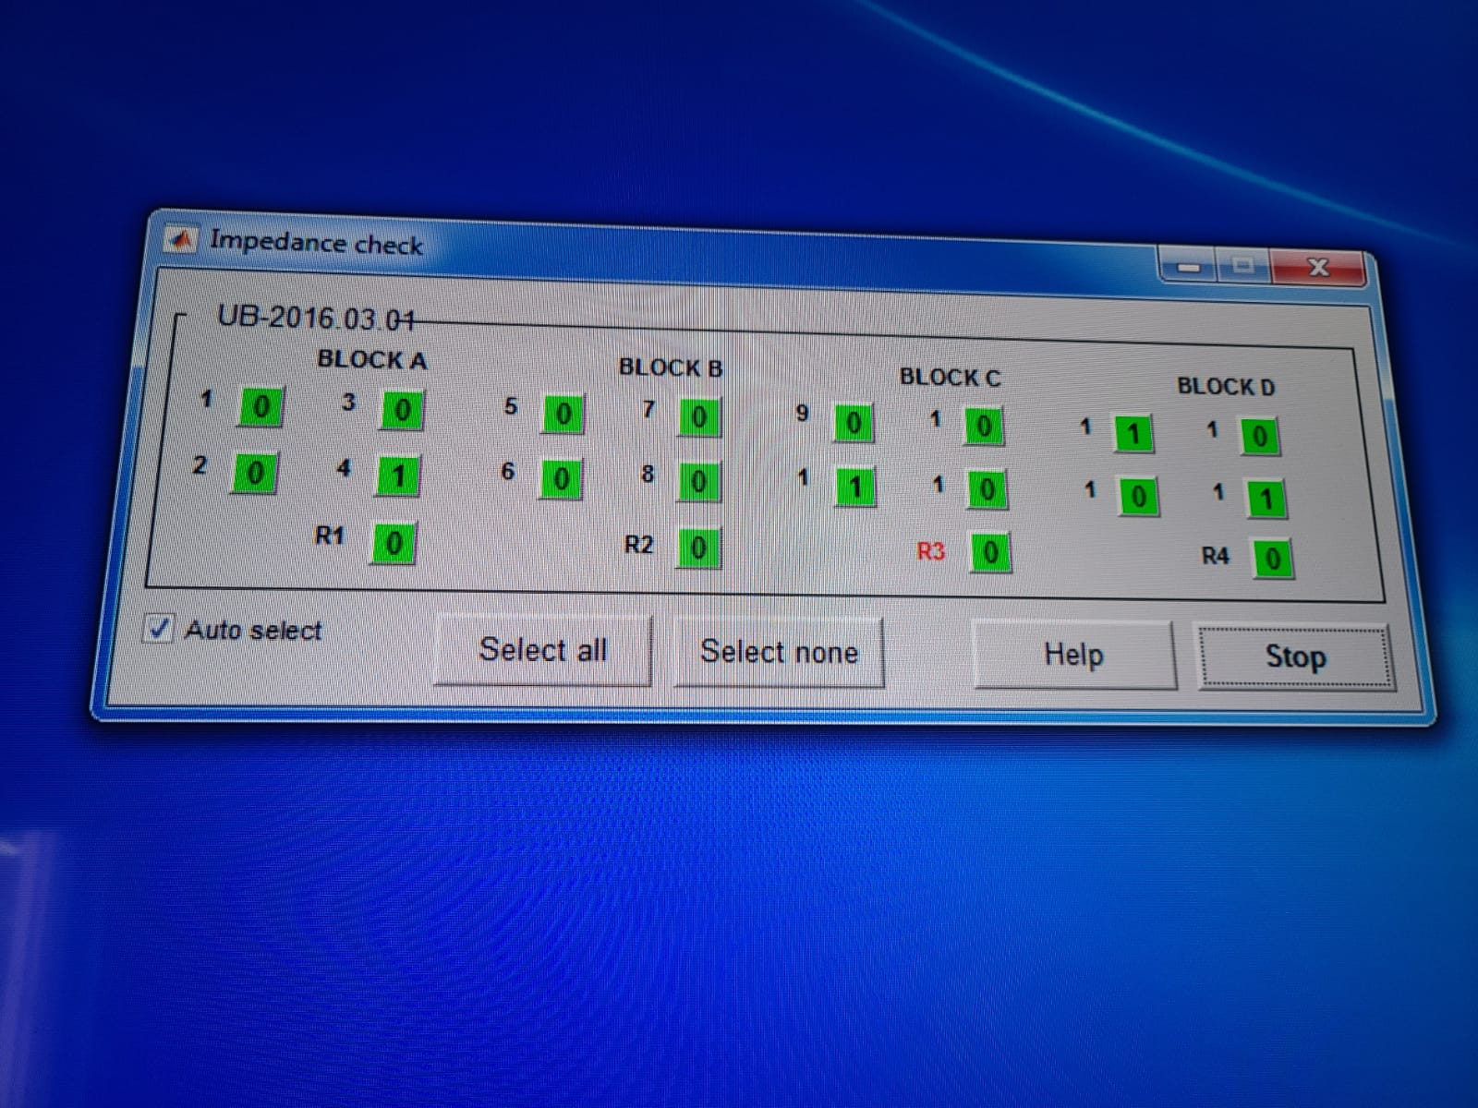

After that we are ready to start. Press OK



The next screen will ask us to Choose a folder which have the model the program will use.

Choose the Best model (according to the accuracy %)